**HTML5 Notes**

Every web page is actually a HTML file. Each HTML file is just a plain-text file, but with a **.html** file extension instead of .txt, and is made up of many HTML tags as well as the content for a web page.

* Do not include spaces in filenames.
* HTML tags are lowercase.
* Create a folder to hold all images.
* Our main html file will be named **index.html**

1. Create a folder **HtmlBasics**

2. In **Brackets** IDE, create a text file named **index.html**

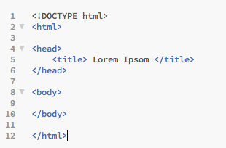 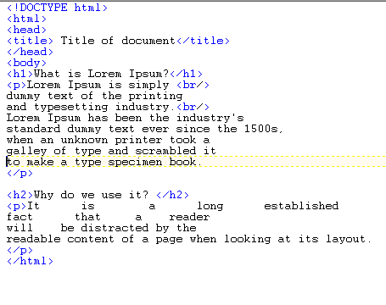

Figure 1 (html file structure) Figure 2. Basic formatting tags

3. HTML elements are written with a start tag and an end tag, with the content in between:

**<tagname>**content**</tagname>The** HTML element is everything from the start tag to the end tag:

Example: **<p>**My first HTML paragraph.**</p>**

* Comments: **<!--** comment **-->**
* Basic Formatting: **<p> <h1> <h2> <h3> <h4> <h5> <h6> <br />**
* Lists: **<ul> <li>**
* Image: **<img>**
* Hypertext Links: **<a>**
* Getting User Data: **<input />**
* Button: **<button>**
* Dividers: **<div> <span>**

*Note: Some tags do not have end tag (***b***r,* **input***,* **img***)* *HTML elements with no content are called empty elements.* **<br>** *is an empty element without a closing tag (the* **<br>** *tag defines a line break). Empty elements can be "closed" in the opening tag like this:* **<br />.**

3a. Go to **http://www.lipsum.com/**and copy portions of the first two paragraphs.

What is Lorem Ipsum?

Lorem Ipsum is simply dummy text of the printing and typesetting industry. Lorem Ipsum has been the industry's standard dummy text ever since the 1500s, when an unknown printer took a galley of type and scrambled it to make a type specimen book.

Why do we use it?

It is a long established fact that a reader will be distracted by the readable content of a page when looking at its layout.

>> *Experiment*: Generate additional lorem ipsum text and paste it in your document.

3b. Insert a variety of html tags: paragraphs, headers, line breaks and add extra space. (Figure 2)

3c. View the web page in a browser: (In Brackets, ***Open in Browser*** plugin must be installed- File/Live Preview)

4. Create Lists (**http://www.w3schools.com/html/html_lists.asp**)

Create a list showing a variety of drinks: coffee, tea and milk:

**<ul>**

**<li>**Coffee**</li>**

**<li>**Tea**</li>**

**<li>**Milk**</li>**

**</ul>**

5. Working with images

The <img> element along with attributes to specify source (src), alternative text (alt) , height and width can serve as placeholders for images.

5a. In the **HtmlBasic** folder, create a subfolder named **img**

5b. Download two images from Wikimedia Commons and save in **img** folder:

[**https://commons.wikimedia.org/wiki/File:TACA_airplanes_SJO_04_2005.jpg**](https://commons.wikimedia.org/wiki/File:TACA_airplanes_SJO_04_2005.jpg)

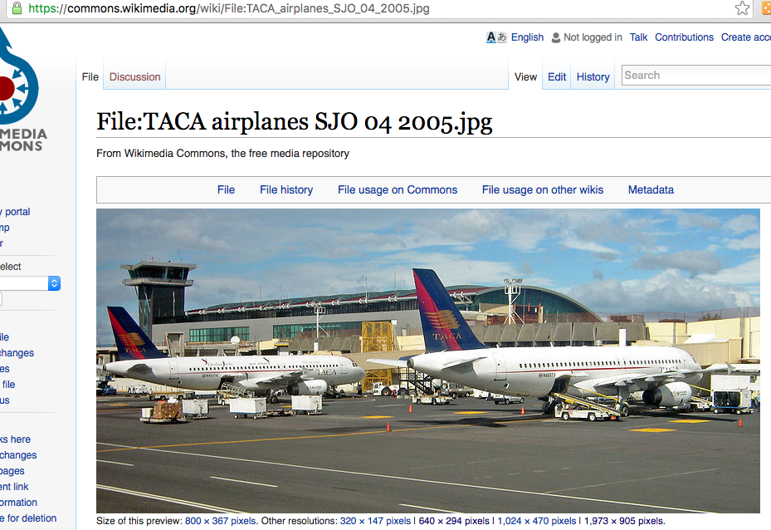

Save the 640 x 294 resolution image as **plane640.jpg** and the 1973 x 905 resolution image as **plane1973.jpg**

5c. Create <img> elements

<h1> Planes </h1>

<img **src**="*img/plane640.jpg*" **alt**="*Small Plane*" **height**=”100px” **width**=”100px”/>

<img **src**="*img/plane1973.jpg*" **alt**="*Large Plane*" />

6. Hypertext Links

5a. Create a link to Georgia College home page:

**<a href=”*http://www.gcsu.edu*”>** Georgia College **</a>**

5b. Create a bookmark and link to it.

Create an **id** for the first **<h1>** element: <h1 **id**=”*lorem*”>

At the bottom of the web page include a link**: <a href=”*#lorem*”>** Go to top of page **< /a>**

*Remember to include the #*

5c. Create html file named **about.html** and store in the same folder as **index.html**. This new file should contain your name, major and hobbies. In **index.html**, add a link to the **about.html** local file:

**<a href=”about.html”>**Go to About Page **</a>**

5d. Make a picture that is a hyperlink by nesting the <img> element within an <a> element

<a **href**=”**http://www.delta.com/”>** <img **src**="*img/plane640.jpg*" **alt**="*Small Plane*" /> </a>

7. Getting User Data (<http://www.w3schools.com/html/html_form_input_types.asp> )

Gather User Data using the **input** text fields. The ***type*** of input specified determines the virtual keyboard that appears. Most often used types are text, email, phone and number. Other ***types*** include: color, date, datetime, search, url + more.

Name:

<input **type**=“*text*” **id**=“name” />

<input type =”text” **id**=”major” **value**=”CSCI” **disabled**/>

<label **for**=“email”> Email </label>

<input **type**=“*email*” **id=“**email” **value**=”cs@gcsu.edu”/>

<label **for**=“phone”>Phone</label>

<input **type**=“***tel***” **id**=“phone” />

<label **for**=“count”>Count</label>

<input **type**=“*number*” **id**=“count” />

The <label> tag is optional. It is mostly useful in desktop applications -- if you click on the label, it will take you to the textfield (labels may not be useful on a mobile app). Experiment and see what happens with the above code.

type, id, value, disabled are all examples of attributes of the input tag. Explore online for more attributes that may be useful for mobile applications.

8. Handling Events

The **<button>** tag defines a clickable button. You can specify the action to perform when the button is clicked.

Note: The **onclick** attribute specifies the JavaScript code that will execute when the button is clicked.

8a. Add a button that will call the JavaScript “alert” method with the message “Hello” when it is clicked

<**button** **type**="button" **onclick**="alert('hello');"> Say Hello</button>

8b. Add a button that will call the JavaScript “alert” method with the value stored in ***name*** input field when the button is clicked.

<**button** **type**="button" **onclick**="alert(document.getElementById('name').value);"**>** Show Name **</button>**

8c. In most of our examples, we will pass the value of the button’s id when the button is pressed:

**<button** **id**=“btnOne” **onclick**=“alert(id)” > Click Me! </button>

In 8c. , when the button is clicked, the **id** of this element is passed as an argument to the alert

There are many events that we can monitor. In the next example practice with **onchange**

8d. Modify the input field for count -- when the count field changes display the message count changed

<input type=”number” id=”count” **onchange**=”alert(‘count changed’);” />

Note: Strings can be expressed with either double or single quotes. When nesting strings you must change the type

9. Working with content dividers

**Block-level Elements**

A block-level element always starts on a new line and takes up the full width available (stretches out to the left and right as far as it can). Examples of block-level elements: <div> <h1> <p>

**Inline Elements**

An inline element does not start on a new line and only takes up as much width as necessary.  
Examples of inline elements: <span> <a> <img>

<div> and <span> elements are often used as a container for other HTML elements. They have no required attributes, but style and class are common.

The <div> element can be used to style *blocks* of content:

<div style="background-color:black; color:white; padding:20px;">  
<h2>London</h2>  
<p>London is the capital city of England. It is the most populous city in the United Kingdom, with a metropolitan area of over 13 million inhabitants.</p>  
</div>

The <span> element can be used to style **parts of the text**:

<h1> My <span style="color:red">Important</span> Heading</h1>

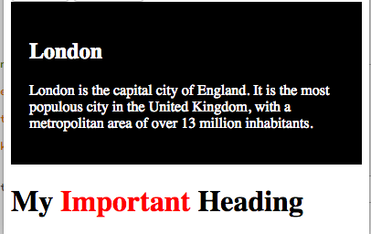

The **class** attribute can be used multiple times in the same HTML document and will be used with CSS to apply styling to a specific element in CSS.

<div **class**="city">  
<h2>London</h2>  
<p>London is the capital city of England. It is the most populous city in the United Kingdom, with a metropolitan area of over 13 million inhabitants.</p>  
</div>

The <span> element can be used to style **parts of the text**:

<h1> My <span **class**=”highlight”>Important</span> Heading</h1>

10. Activity 1: Correcting html Errors

Download the D2L Folder **beeErrors.zip.**

Correct the **index.html** so that the following web page is displayed:

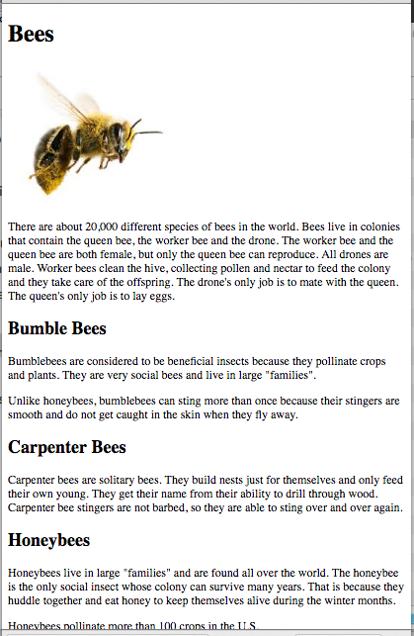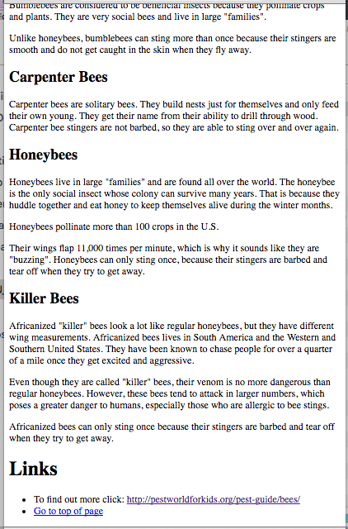

Note:

The category descriptions (bubble bees, carpenter bees, honey bees and killer bees) should be <h2> header style.

Notice the **Link** section is formatted in a list with hypertext links.

When you click on the URL <http://pestworldforkids.org/pest-guide/bees> it should go to the site.

When you click on “Go to top of page” the screen should scroll to the “about” section at the top of the page.

11. **Activity 2**: Create a new folder named **Sunshine**. Search online for an animate gif of sunshine and save it in your **img** folder. Create a page named “**index.html**” that displays the **image** of sunshine, a **name** text field, a **password** text field, and login button. When the button is pressed say “Smile….” + value of whatever is in the **name** field. The image of the sunshine should display as 320px high and 420px wide.